LIFE SAVER

( A FIRST AID GUIDE APP)

BERMILLO, CHEZNA

GAITAN, KRISTINE

SALAVARIA, CLARICE

SOREÑO, ANGELINE

BSINFOTECH 3B

JULY 31, 2023

**User Manual:**

1. **App Introduction Page**

* This page will act as the apps on boarding screen. It is intended to give a general overview of the app and explain what function it will do.

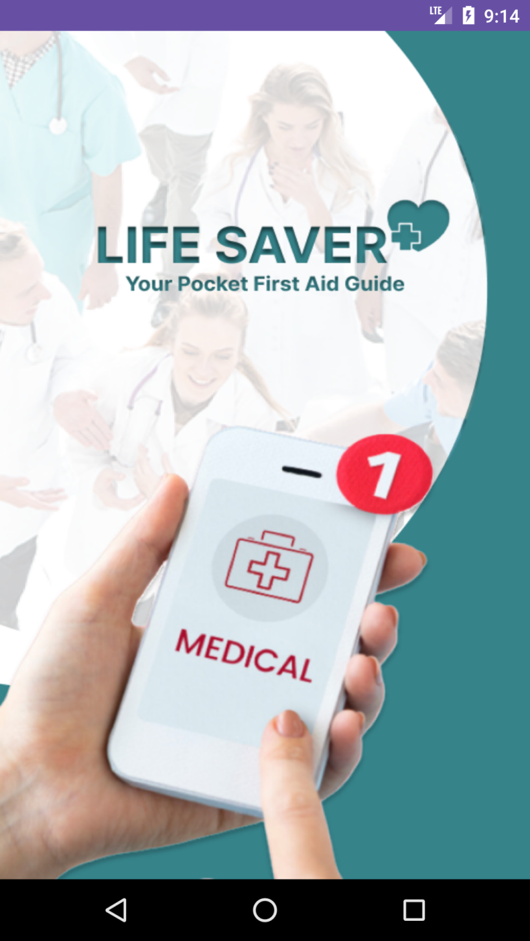

1. **Homepage**

* This is the app's home page. The user will be taken here after successfully logging in to their account.
* There are two categories on the homepage. both the category for medical emergency contacts or hotlines that a user could utilize if he or she needs assistance and the category for the many emergencies that require a proper first aid guide.

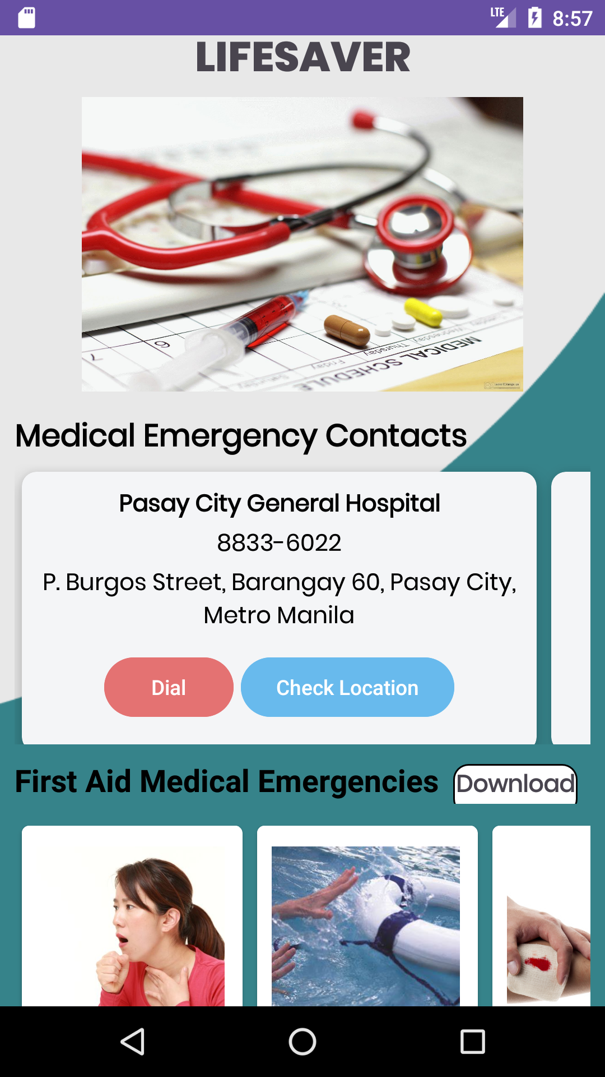

1. **First Aid Guide/Tips Page**

* In the first category, when a user clicks on a specific medical issue, information about the disease, a step-by-step guidance for providing first aid, and resources for learning about pain or links will all show.

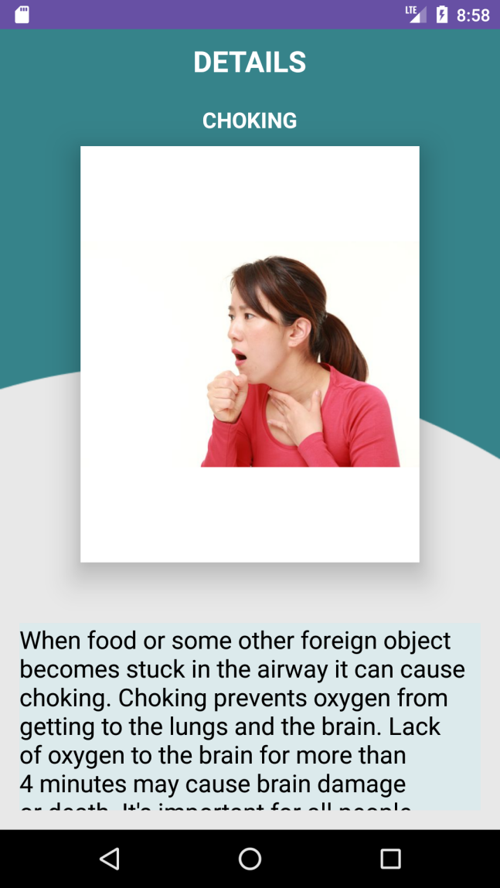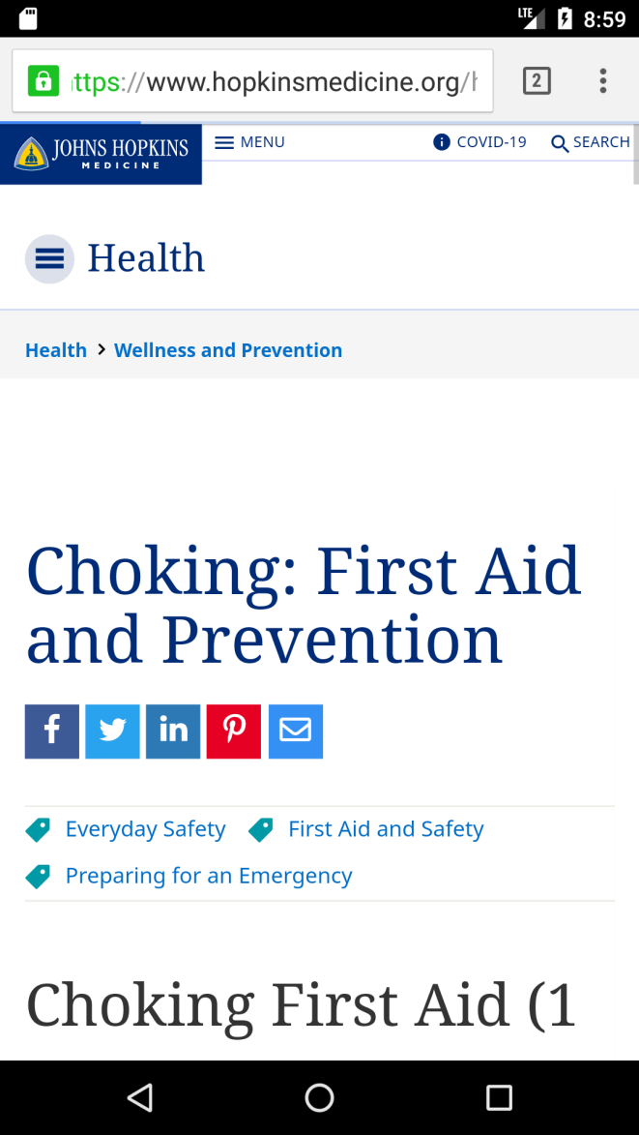

1. **Medical Emergency Contacts**

* 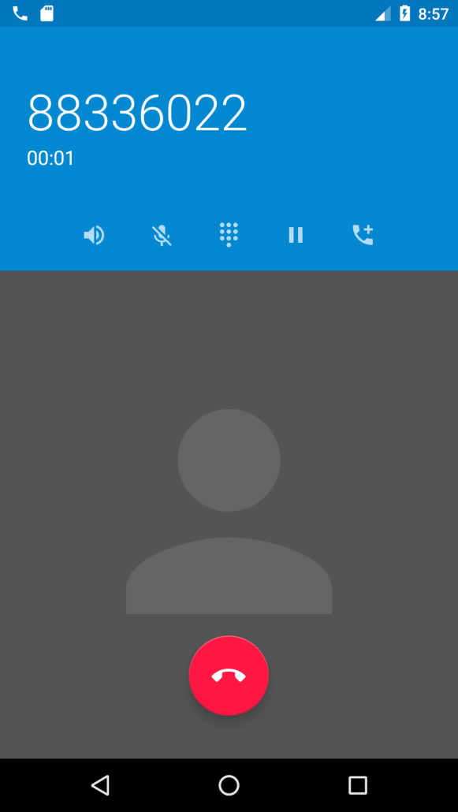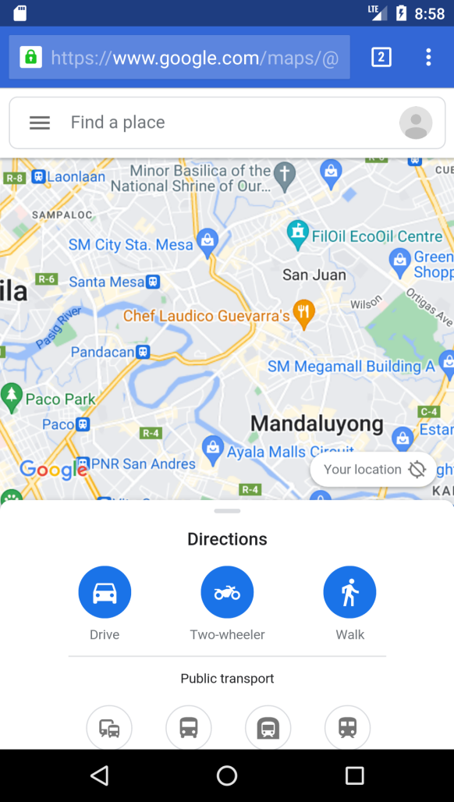Users will be given a list of medical emergency contacts or hotlines that they can call when they require medical assistance that is close to their current location. You can use the direct dialing option to save time, and you can also use the map link to quickly find the closest hospital without having to fight.